

Capstone Report - Spring 2022

Using ensembled pre-trained CNN networks to classify MRI images of patients with Alzheimer’s Disease

Kristin Levine

Advisor: Amir Jafari

The George Washington University, Washington DC

Data Science Program

Abstract

The goal of this project is to look at patients with possible Alzheimer’s disease (AD), using MRI images to help decide if a patient is cognitively normal, has very mild cognitive impairment, has mild cognitive impairment, or moderate cognitive impairment. AD can be hard to diagnose and even experienced neurologists struggle to read MRIs accurately. Lack of data remains a problem in neurodegenerative disease research, so I investigated flipping and shifting images to determine which types of data augmentation is most helpful. I used three different pre-trained CNN models (ResNet50, VGG16, and Xception) and ensembled them using a Random Forest to classify the images, achieving greater than 83% accuracy on the 4-class classification problem. Finally, I also attempted to create my own dataset from original MRI images, by accessing original patient data from ADNI and extracting my own slides for classification.

Contents

1 Introduction 3

2 Description of the Data Set 3

3 Related Work/Algorithms Used 4

4 Experimental Setup 5

5 Results 7

5.1 Individual Model Results 7

5.2 Ensembled Results 10

6 Discussion 11

7 Conclusion 12

8 Attempts at Creating my Own Dataset 13

9 Bibliography 17

# Introduction

Alzheimer’s disease is the most common dementia, yet it remains difficult to diagnose. PET scans to measure amyloid protein build-up and cerebrospinal fluid (CSF) biomarkers can help to provide an accurate diagnosis, however they are expensive and invasive tests. MRIs are much more accessible.

However, MRIs are difficult to read and depend on an experienced neurologist to interpret them. A dependable and accurate ML learning model has the potential to help a general practitioner in a small town to read an MRI as accurately as a specialist at a large research hospital. There has been progress in developing ML models for other conditions like breast cancer. [2](https://paperpile.com/c/wOWd5O/lxpf) [Yala]

Being able to differentiate mild cognitive impairment from normal cognition and Alzheimer’s disease is also important for clinical trials, as potential treatments are more likely to be effective before the condition progresses to AD.

In the past, neurological ML models mainly used MRIs for feature extraction, i.e. to get a measurement for a part of the brain, such as the size of the hippocampus. While this has proved helpful, there is significant domain knowledge required in order to understand which parts of the brain to target. Extracting features is challenging; we also can’t be sure that we are picking out the most helpful features.

CNNs offer a different approach of using computer vision to look at the image as a whole. There is less domain knowledge needed as the computer decides which are the relevant features.

However, using a CNN network is not without its own challenges. CNN networks work best when you have lots of data; however, in dementia research there is a lack of labeled images. While I’ve read about some interesting approaches, including using unlabeled data to help train a network [3](https://paperpile.com/c/wOWd5O/zRul), for this project I am using labeled datasets.

When we have less data that we’d like, one way around that problem is to augment our data. In this paper, I’m examining three different approaches: using the original non-augmented dataset, using a flipped training set, and using a shifted training set.

Another method of dealing with a lack of data when creating a CNN model is to use transfer learning, i.e. using pretrained networks as a starting point for your model.While there has been some discussion about whether it is useful to use networks pre-trained on ImageNet with medical data [4](https://paperpile.com/c/wOWd5O/B5Hy), I’m going to investigate pretrained models for this project. There are plenty of other studies that have used these pretrained models to look at Alzheimer’s imaging data. [5](https://paperpile.com/c/wOWd5O/pM6X) [6](https://paperpile.com/c/wOWd5O/Pzkv) [7](https://paperpile.com/c/wOWd5O/1uMv)

# Description of the Data Set

I’ve used a Kaggle dataset for this project: [Alzheimer’s Dataset (4 class of images).](https://www.kaggle.com/datasets/tourist55/alzheimers-dataset-4-class-of-images)  This dataset contains approximately 5000 jpg images (slices) taken from MRI images of possible Alzheimer’s patients, divided into 4 categories: non-demented, very mild demented, mild demented, and moderate demented.

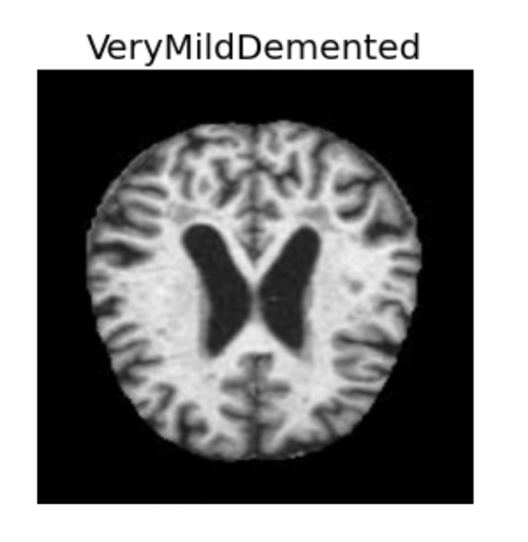

ADD SAMPLE IMAGES here

The original dataset was quite unbalanced

|  |  |
| --- | --- |
| Train Set | # Images |
| Non-impaired (cognitively normal) | 2560 |
| Very mild impairment | 1792 |
| Mild impairment | 717 |
| Moderate impairment | 52 |

|  |  |
| --- | --- |
| Test Set | # Images |
| Non-impaired (cognitively normal) | 640 |
| Very mild impairment | 448 |
| Mild impairment | 179 |
| Moderate impairment | 12 |

You can see that as people become more impaired, we have fewer images of their condition.

# Related Work/Algorithms Used

Most of the similar studies I found used only one pretrained network to classify the images, although they sometimes compared the results from more than one. Some of the pre-trained CNNs used were: VGG-19 [5](https://paperpile.com/c/wOWd5O/pM6X), ResNext101 [6](https://paperpile.com/c/wOWd5O/Pzkv), GoogLeNet [11](https://paperpile.com/c/wOWd5O/gqAR), and Inception [12](https://paperpile.com/c/wOWd5O/73EK).

Fang et al’s 2020 study [9](https://paperpile.com/c/wOWd5O/Ffko) is the most similar one I’ve come across to what I’m proposing. They also extracted 2D slices from the MRI and PET images, and then used three different pre-trained networks (GoogLeNet, ResNet, and DenseNet) to get a probabilistic score for each image. Finally, they used a Decision Tree to combine the probabilistic scores from each CNN and get their final prediction.

The three pre-trained CNN networks I selected were: ResNet50, VGG16, and Xception.

ResNet50 was the first CNN model to introduce the concept of a skip connection: a signal feeding into a layer is also added to the output of another layer that is located higher up in the stack. It won the ImageNet challenge in 2015. Input shape (224, 224, 3)

VGG16 won the ImageNet competition in 2014 and uses smaller filter, but a deeper network. It was named after the Visual Geometry Group from Oxford that developed it. Input shape (224, 224, 3)

Xception used depthwise separable convolution and improves upon the Inception model. It dates from 2017 and is 71 layers deep. Input shape (299, 299, 3)

Finally, I used a standard random forest algorithm to ensemble these three different models together.

# Experimental Setup

Because the original dataset was so imbalanced, my first step was to figure out how to augment the data. Here were the original numbers:

|  |  |
| --- | --- |
| Train Set | # Images |
| Non-impaired (cognitively normal) | 2560 |
| Very mild impairment | 1792 |
| Mild impairment | 717 |
| Moderate impairment | 52 |

|  |  |
| --- | --- |
| Test Set | # Images |
| Non-impaired (cognitively normal) | 640 |
| Very mild impairment | 448 |
| Mild impairment | 179 |
| Moderate impairment | 12 |

I decided to first divide the train set into train/validation, using a 70/30 split. I did this by moving 30% of the training images to a separate validation folder. The final non-augmented dataset consisted of:

|  |  |
| --- | --- |
| Train Set | # Images |
| Non-impaired (cognitively normal) | 1792 |
| Very mild impairment | 1254 |
| Mild impairment | 502 |
| Moderate impairment | 36 |

|  |  |
| --- | --- |
| Validation Set | # Images |
| Non-impaired (cognitively normal) | 768 |
| Very mild impairment | 538 |
| Mild impairment | 215 |
| Moderate impairment | 16 |

|  |  |
| --- | --- |
| Test Set | # Images |
| Non-impaired (cognitively normal) | 640 |
| Very mild impairment | 448 |
| Mild impairment | 179 |
| Moderate impairment | 12 |

I decided to perform the augmentation ONLY on the test set. A large problem with MRI CNN networks is overfitting. You can train a network to identify images in one set, but they often do not work on a different dataset. As the test set would, of course, not be augmented, I decided to not augment the validation set as well, giving the model the best chance to train correctly.

**Flipping the Data**

First, I decided to augment the data by flipping the images. I used cv2.flip() to flip the jpgs in three directions: horizontally (using flip code 1), vertically (using flip code 0) and around both axes (using flip code -1). I also balanced the data for all the classes, except for the smallest minority class (I didn’t have enough data to do that) by selecting varying numbers of the original images to flip. INCLUDE examples here.

|  |  |
| --- | --- |
| Flipped Train Set | # Images |
| Non-impaired (cognitively normal) | 2008 |
| Very mild impairment | 2008 |
| Mild impairment | 2008 |
| Moderate impairment | 144 |

The validation and test sets for the flipped data remained the same as for the non-augmented data.

**Shifting the Data**

I also wanted to try a transformation that would allow me to completely balance the dataset. I used cv2.warpAffine to slightly shift all the images. By using more shifts on the smallest class, I was able to balance the dataset. This seemed like it might be a good transformation to try because MRIs are all taken at slightly different angles, depending on the machine and the person. INCLUDE example.

|  |  |
| --- | --- |
| Shifted Train Set | # Images |
| Non-impaired (cognitively normal) | 2008 |
| Very mild impairment | 2008 |
| Mild impairment | 2008 |
| Moderate impairment | 2016 |

After augmenting the data, I had effectively created 3 different training sets: one with no augmentation, one with flipping the images, and one with shifted images.

Next, I ran each pre-trained model on each dataset, for a total of nine models. I then compared the results and selected the three best models to ensemble into a final model. See figure below to see how this was done:

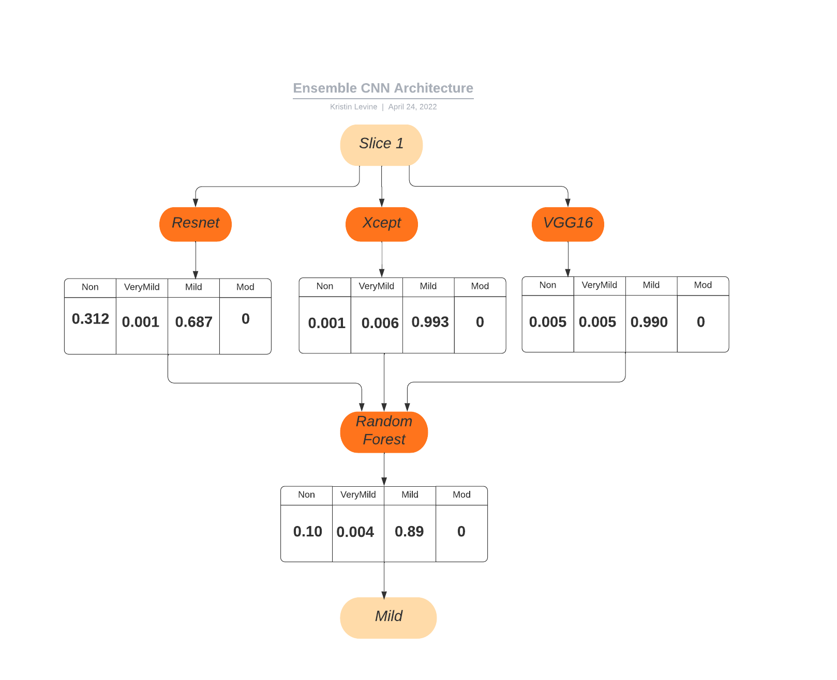

# Results

## Individual Model Results

I trained all the models on Google Colab Pro, using a batch size of 32, with dropout of 0.1. I trained the frozen layers for 10 epochs (20 epochs for Shifted VGG16 model) with a learning rate of 0.001, using both early stopping and reduce LR on plateau callbacks. I then unfroze each model and trained it for an additional 10 epochs, starting with a learning rate of 0.0001. Here’s a summary table of all my results:

|  |  |  |  |  |
| --- | --- | --- | --- | --- |
| Model | Augmentation | Train Acc | Val Acc | Test Acc |
| ResNet | None | 1.00 | 0.9740 | 0.7303 |
| VGG16 | None | 0.8597 | 0.8699 | 0.6529 |
| Xception | None | 0.9980 | 0.9453 | 0.6701 |
|  |  |  |  |  |
| ResNet | Flip | 0.9992 | 0.9818 | 0.7224 |
| VGG16 | Flip | 0.9162 | 0.8530 | 0.6482 |
| Xception | Flip | 0.9990 | 0.9655 | 0.7177 |
|  |  |  |  |  |
| ResNet | Shift | 0.9981 | 0.9876 | 0.7482 |
| VGG16* | Shift | 0.9999 | 0.9759 | 0.7240 |
| Xception | Shift | 0.9994 | 0.9681 | 0.7209 |
|  |  |  |  |  |
| Combined |  |  |  | 0.8307 |

*trained 20 epochs, as I realized this model was taking longer to train

Here’s a closer look at the individual model test set results for the best models – for all CNNs this was the shifted model.

**ResNet50**

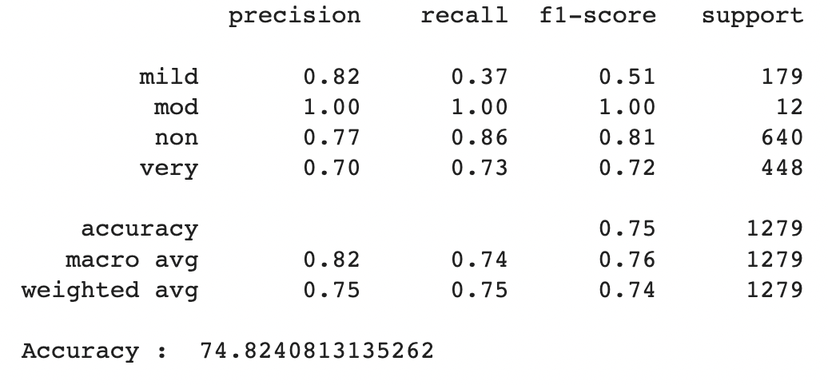

**VGG16**

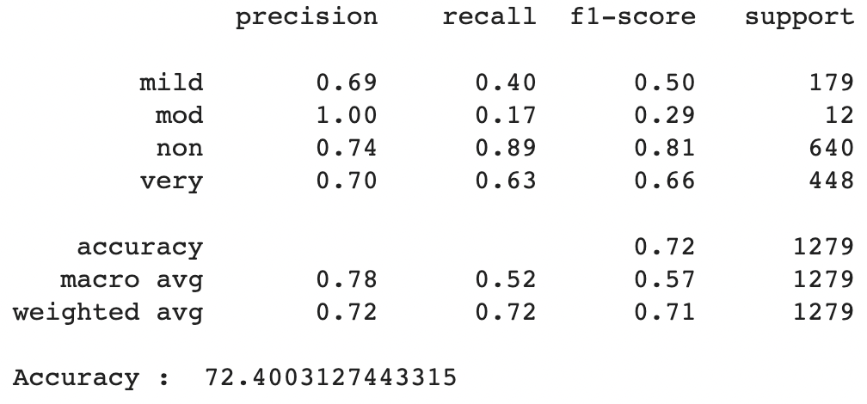

**Xception**

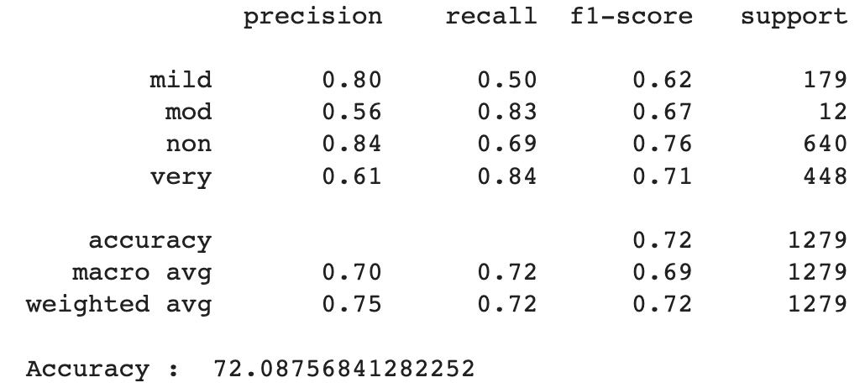

By ensembling the models, we can draw from their different strengths and hopefully minimize their weaknesses.

## Ensembled Results

To ensembled the models, I took the individual CNN model with the best results – this was the shifted models worked for all three of the pre-trained models. I created a data frame of the results (see sample below), and then trained it again using a random forest, with a 70/30 train test split.

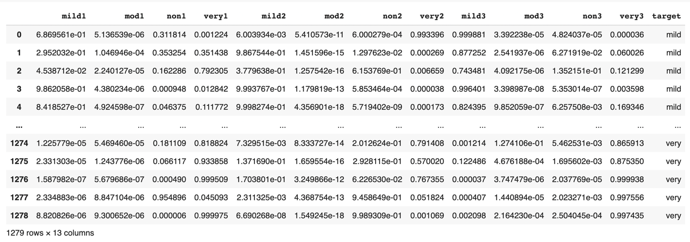

Here are the final results of that model.

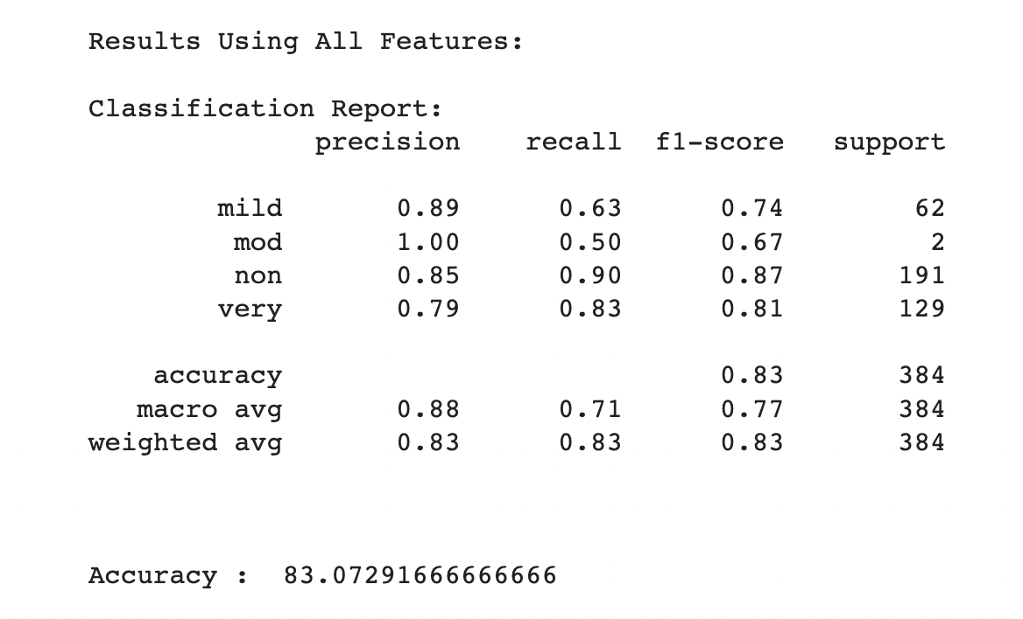

The confusion matrix below provides even more info.

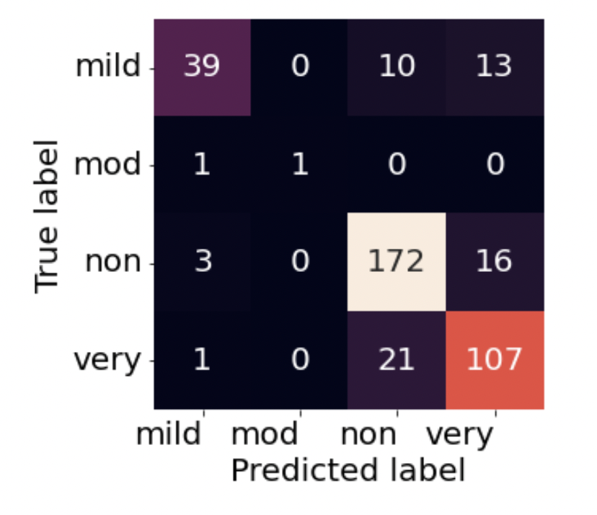

# Discussion

As we can see each of the pretrained models did an excellent job on the training and validations sets; all of them struggled to deal with the training set.

It is interesting to note that flipping the images did NOT help our models; in fact, for two of our models, ResNet and VGG16, it made it worse. This is probably due to the fact that all these images were already standardized to face in one direction. It is also unclear if you can flip images of the brain – different hemispheres play different roles. It is possible that flipping the images actually confuses the models, because it now sees changes in a different part of the brain.

Shifting our images, however, was helpful. It improved our test accuracy for all three of our models – improving our ResNet model by about 2%, the Xception model by 5%, and the VGG16 model by 7%.

|  |  |  |  |
| --- | --- | --- | --- |
| Model | Test Acc (No Aug) | Test Acc  (Shifted) | Improvement |
| ResNet | 0.7303 | 0.7482 | 0.0179 |
| VGG16 | 0.6529 | 0.7240 | 0.0711 |
| Xception | 0.6701 | 0.7209 | 0.0508 |

We can see that the models also varied in how well they classified each category.

|  |  |  |  |  |  |  |  |  |  |
| --- | --- | --- | --- | --- | --- | --- | --- | --- | --- |
| Class | Precision | | | Recall | | | F1-score | | |
|  | R | V | X | R | V | X | R | V | X |
| Mild | 0.82 | 0.69 | 0.80 | 0.37 | 0.40 | 0.50 | 0.51 | 0.51 | 0.62 |
| Mod | 1.00 | 1.00 | 0.56 | 1.00 | 0.17 | 0.83 | 1.00 | 0.29 | 0.67 |
| Non | 0.77 | 0.74 | 0.84 | 0.86 | 0.89 | 0.69 | 0.81 | 0.81 | 0.76 |
| Very | 0.70 | 0.70 | 0.61 | 0.73 | 0.63 | 0.84 | 0.72 | 0.66 | 0.71 |

For the “mild” class:

* ResNet had the best precision (0.82)
* Xception had the best recall (0.50) and f1 score (0.62)

For example, for the “non” class:

* Xception had the best precision (0.84);
* VGG16 had the best recall at (0.89);
* VGG16 and ResNet had similar f1 scores (0.81)

ADD Discussion of other classes

Ensembling the models results in a dramatic improvement in our accuracy for the test set data, ranging from 8-11%.

|  |  |  |  |
| --- | --- | --- | --- |
| Model | Test Acc  (Shifted) | Test Acc  (Ensembled) | Improvement |
| ResNet | 0.7482 | 0.8307 | 0.0825 |
| VGG16 | 0.7240 | 0.8307 | 0.1067 |
| Xception | 0.7209 | 0.8307 | 0.1098 |

# Conclusion

When comparing non-augmented, flipped, and shifted datasets, shifting the images to create more data improved test set accuracy – even as it had no effect on the accuracy of train and validation sets. In this study, it improved test performance by 2-7%, depending on the model used.

In a field such as Alzheimer’s research, shifting images to create more data is a way to improve test-set performance and perhaps increase the transferability of the model to other datasets.

Even when various models provide good results individually on test and validation sets, performance can be increased on the test set by ensembling them together to take advantages of their individuals strengths and minimize their weaknesses. In this study, ensembling three models improved test performance by 8-11%, even when all of the models had excellent accuracy on the training and validation sets.

Ensembling is another method that could be put to good use when dealing with small, limited datasets in neurodegenerative disease research.

Further research directions might include more detained investigations into the optional amount to shift images; exploring more pre-trained models; and/or investigating other image transformations such as brightness or normalization techniques.

# Attempts at Creating my Own Dataset

Finally, I wanted to investigate where these data sets came from. There was very little information about this dataset on Kaggle – no info on where it came from, how the patients were diagnosed. It also contained no genetic or clinic data.

I’ve also used original MRI images in the Nifti format from the Alzheimer’s Disease Neuroimaging Initiative (ADNI), a public-private collaboration studying Alzheimer’s disease. The initiative has been around since 2004 [1](https://paperpile.com/c/wOWd5O/hKEC) and collects clinical, cognitive, imaging, biomarker, and genetic data to share with researchers.

I started by downloading original NiFTI files from ADNI that fell into three different categories: cognitively normal (CN), mild cognitive impairment (MCI), and Alzheimer’s disease (AD). Here are three sample images:

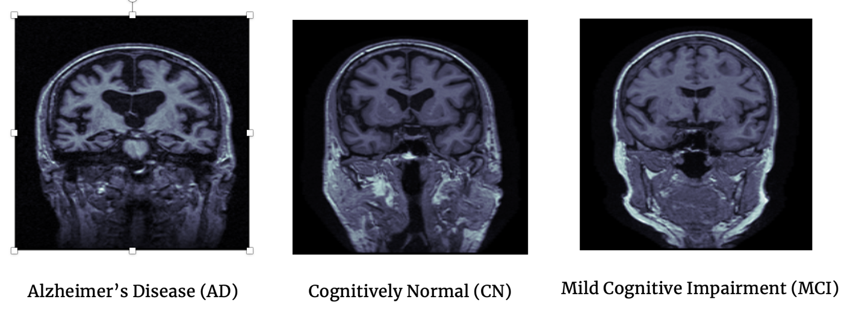

Using a Python package called nibabel I was able to view these 3D images, as well as take slices from each of the different orientations.

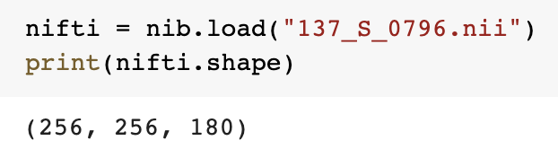

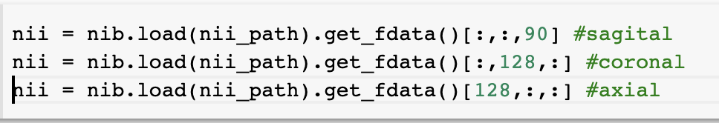

Here is an example of slices from each of the three different orientations:

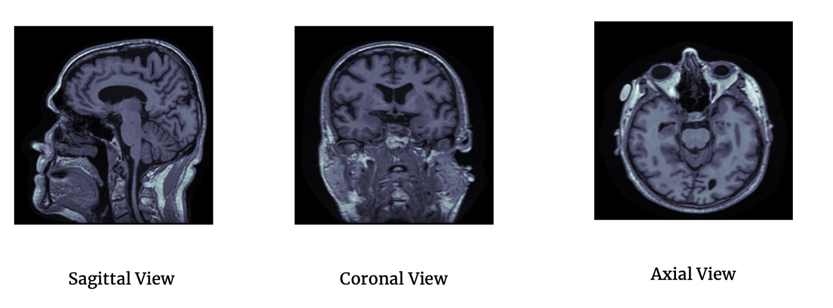

You may notice that these images look different than the images used in the Kaggle dataset. These are the raw images that have not yet had the “skull stripping” done – a complicated process, usually using the FreeSurfer [link here] software.

You may also notice that all of the images in the Kaggle dataset are from the same orientation. My idea was to extract a set of slices from these images, and then try a similar set of pretrained models on this new set of slices.

I wanted to try skipping the complicated “preprocessing” step of using FreeSurfer to remove the skull and other image artifacts. While I was able to extract the slices (I did 21 in each orientation) and I got good train/and validation accuracy, but test accuracy refused to budge, hovering right about 40%, which with only three classes, wasn’t much better than chance.

|  |  |  |  |
| --- | --- | --- | --- |
| Model | Train Acc | Val Acc | Test Acc |
| ResNet | 0.9999 | 0.9982 | 0.4018 |
| VGG16 | 0.9741 | 0.9667 | 0.3993 |
| Xception | 0.9999 | 0.9977 | 0.3900 |

I realized that the FreeSurfer preprocessing did appear to be necessary – without the preprocessing there was just too much extra/confusing data. I liken it to looking for a needle in a haystack. If you know the needle (the information we need) is in the bottom half of the haystack, it will make your search a lot faster, if we remove the top half of the hay. A brain disorder is unlike to be seen in the bones of the skull; therefore, if we remove that info, we can actually create a better model.

Luckily, in addition to raw MRI images, ADNI also contains NiFTI images that have been preprocessed (skull stripped) with the FreeSurfer software. As I did not want to bite off more than I could chew, I downloaded _________ of these images.

I decided to study the images from the Kaggle dataset, and decided to take images that visually looked similar and were from the same orientation. In manually exploring 10 images from each class, I discovered another challenge when working with MRI images – the relevant slices vary from person to person. Here’s an example:

#Patient 3

patient_id = labels.Subject.iloc[3]

nii_path = ROOT_PATH + patient_id + "_FreeSurfer.nii"

label = labels['Group'].iloc[3]

image = nib.load(nii_path).get_fdata()[:,:,160:180, 0]

plot_slices(4, 5, 256, 256, image)

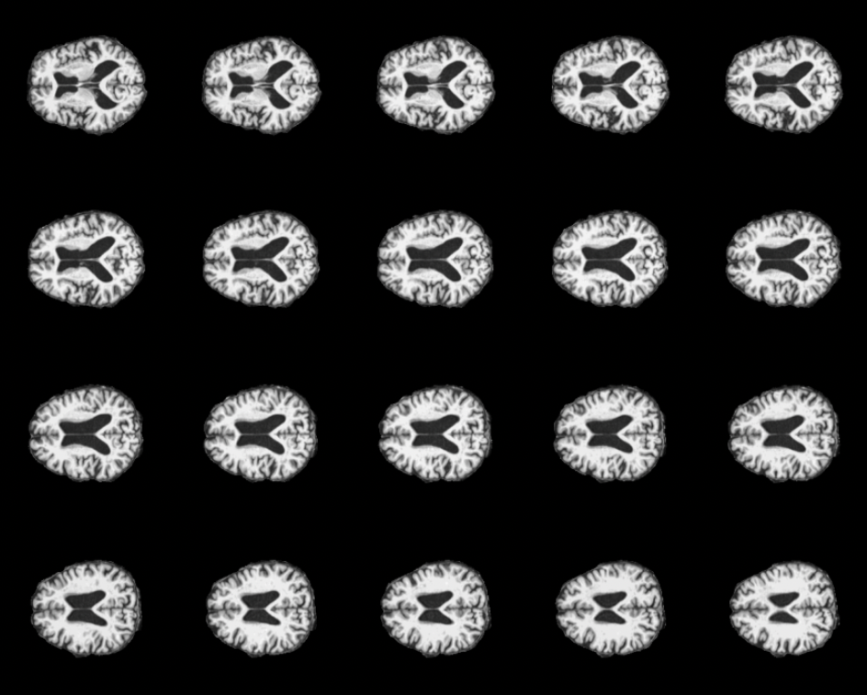

For example, for patient 3 in this example, nib.load(nii_path).get_fdata()[:,:,160:180, 0]

Got me the slices that I thought had the best chance of containing relevant information. However, for patient 9 below, the range was: nib.load(nii_path).get_fdata()[:,:,135:155, 0]

If I only took 21 slices in an orientation, I might miss most (if not all) of the relevant info.

#Patient 9

patient_id = labels.Subject.iloc[9]

nii_path = ROOT_PATH + patient_id + "_FreeSurfer.nii"

label = labels['Group'].iloc[9]

image = nib.load(nii_path).get_fdata()[:,:,135:155, 0]

plot_slices(4, 5, 256, 256, image)

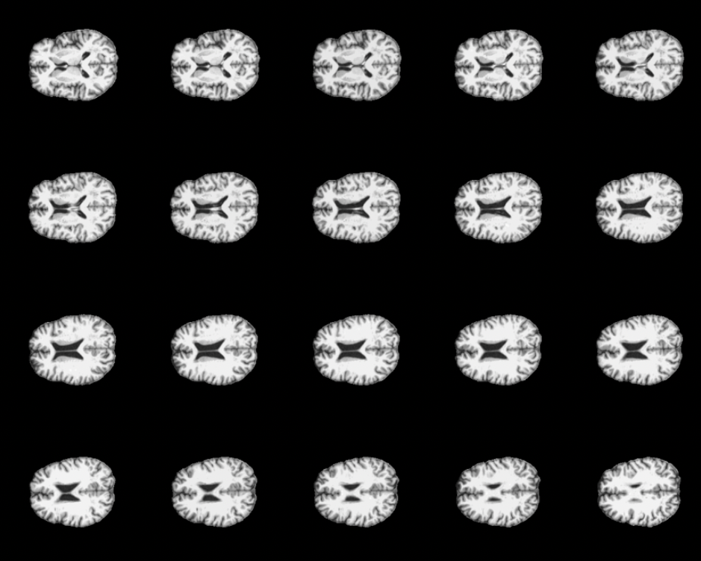

“Tolerance for failure” – didn’t worked out quite as I expected, learned a lot, came up with some interesting models as well.

# Bibliography

|  |  |
| --- | --- |
| [1] | R. Guerraoui, "Genuine atomic multicast in asynchronous distributed systems," *Theoretical,* 2001. |
| [2] | V. P. a. L. Iftode, "Byzantine fault tolerant public key authentication in peer-to-peer," *Computer Networks,,* 2006.. |
| [3] | J. R. Douceur, *IPTPS '01.,* 2001. |